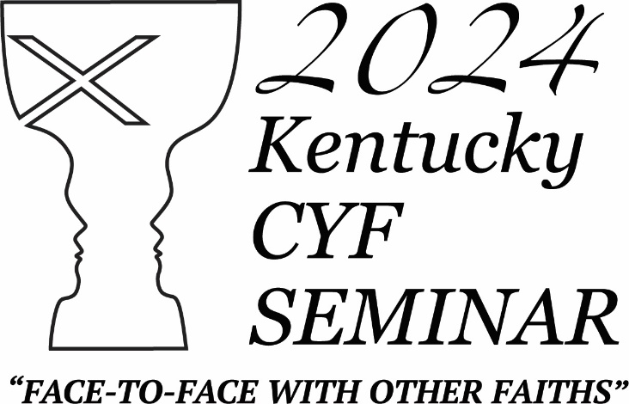
JUNE 11-18, 2024
What is CYF Seminar?
CYF seminar is a mobile classroom experience for high school students and college first-year students. The group will travel to Washington DC and New York City. We will experience diverse cultures, new adventures, and learn more about our faith and the history of religious pluralism in our country.
What is this year’s study theme?
This year’s theme is “Face to Face with Other Faiths.” Religion affects our daily lives. It forms the foundation for a wide range of moral codes. It is the driving force behind people’s conduct. It influences the actions of nations on the world stage resulting in conflict and civil unrest. By coming face to face with other faiths in our week together, our hope is to learn more about the religious foundations and struggles for freedom of faith in our nation; to achieve a better understanding of the beliefs of others; to develop a greater tolerance for people who worship God differently; and perhaps to better appreciate our Christian faith—the ways we are different and the ways we are alike. 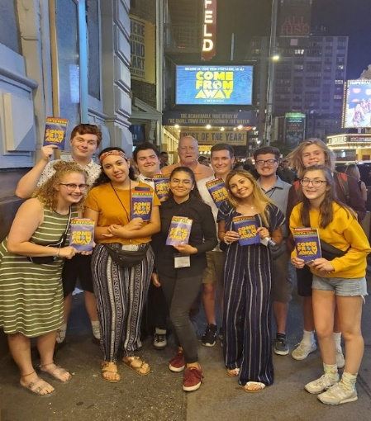 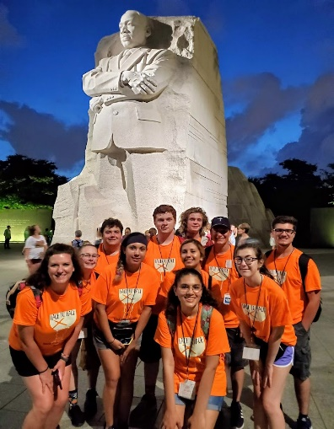
What will we be doing?
Though the itinerary is still in process, we will depart Louisville for a flight to Washington DC. While in our nation’s Capital we will share communion at the National Cathedral; visit the Archives for a look at the Constitution and Bill of Rights; tour all monuments and various houses of worship; visit the Holocaust Museum, the Smithsonian’s American History and African American Museums, Arlington Cemetery for the Changing of the Guard, and the Capitol Building where we will meet with a Kentucky Representative; and walks by the White House and Ford’s Theater.
We will leave on Amtrak for a morning and early afternoon trip to New York City, arriving in time to check into our rooms, catch a subway to Brooklyn, and walk across the famous bridge into the city. The Big Apple portion of our trip will feature tours of houses of faith and opportunities to experience the many ethnic traditions that abound in the city. We will also spend time at Ground Zero and the 911 Museum, view the Statue of Liberty from the Staten Island Ferry, celebrate communion in Central Park; and enjoy the wonderful international cuisine and the delight of eating a New York slice of pizza. We will worship with the Jewish congregation at Emanu El and at the historic Riverside Church and attend a yet to be determined Broadway play.
You can be a part of the 2024 CYF Seminar “Face to Face with Other Faiths” by filling out the Registration Form, Health Treatment form and signing the Covenant, then sending your refundable reservation deposit of $100, by March 15. Since we are anticipating a larger group this year, we encourage you to meet this first deadline to assure you have a place. Please make checks payable to: The Christian Church In Kentucky and mail the deposit and forms to: The Christian Church In Kentucky, P. O. Box 910503, Lexington, KY 40591. Designate your check for “CYF Seminar.” Subsequent payments of $400 are due April 1, May 1, and June 1. An initial deposit of $500 must be received no later than April 10, and there will be no refund of deposits after airline and train tickets are purchased. We are making every effort to procure scholarships from sponsors, and we will pass those savings on to participants as they are available. Individual congregations are encouraged to help underwrite the cost for their youth.
Registrants will be notified of team meetings and more detailed plans as finalized.
Please contact Rev Dr. Mike Gatton (mgatton0617@gmail.com), 502-548-6311, with questions. We are looking forward to traveling and learning with you.
Agape, Mike
CYF SEMINAR REGISTRATION
FACE TO FACE WITH OTHER FAITHS”
JUNE 11-18, 2024
Please use ink. Print all information. Complete entire form.

Name_______________________________________________________
Address_____________________________________________________
City_______________________________________, KY, Zip___________
Birth date_______________ Age_____ Grade_____ Gender______
T-shirt size: ______________
Home Phone___________________ Emergency Phone_______________
Youth Cell Phone: _____________________________________________
Student’s E-Mail_______________________________________________
Parent Mobile Phone Parent(s) E-Mail_______________________________________________
Home Congregation____________________________________________

__ Yes, the region/area has permission to photograph my child for promotional purposes including internet, newsletters, and film.
__ No, do not photograph my child.

Have you ever traveled by air? ___________________________________
Have you ever visited Washington DC or New York City? ______________

HEALTH TREATMENT PERMISSION FORM
2024 CYF SEMINAR

Name of youth participant ______________________________________
Date of Birth ____/_______/________ Phone# ____________________________
Grade in school (completed) ___________________________________________
Full Address ________________________________________________________
Emergency contact person (other than parent) and phone numbers

Name of Medical Insurance Company_________________________________
Policy number ______________________________________
Physician Name ________________________Phone number ________________
List any medical allergies, medications, medical problems, or other pertinent information. ________________________________________________________

I understand that, in the event medical treatment is required, every effort will be made to contact me. However, if I cannot be reached, I give my permission for a representative of the CCK CYF SEMINAR to secure the services of a licensed physician to provide the care necessary.

Signed: ___________________________________ Date ____________________
(Parent or legal guardian)

SEMINAR COVENANT

I have read and agree to the following code of conduct:
- I will always be respectful to all people and conduct myself according to the trip environment.
- I understand that possession of drugs, alcohol, tobacco, or weapons of any kind, are prohibited, and I will be sent home immediately at my own expense if these items are found in my possession.
- I will always stay with the study group and understand that wandering off on my own or with another person without permission is unacceptable and warrants termination of my trip at my expense.
- I covenant to enjoy this trip as an opportunity to know God and learn about other cultures to know people of other faiths and acquire a greater understanding of their beliefs as well as a greater appreciation of my own. Therefore, I will participate fully in all activities endeavoring to get the most out of my trip.
- I will not damage property and understand that I will be held financially responsible for any repairs or restitution resulting from my actions.
- I promise not to steal from anyone.
- I will not get any piercings or tattoos on this trip.
- I understand that I may be sent home at my own expense for consistently behaving in a way that does not reflect the grace and love that is associated with persons who claim the Christian faith.

Parent(s) Signature________________________________ Date________
Participant’s Signature_____________________________ Date________

